TC-760/1100ABC/1500A Automatic Windows Patching Machine Product Introduction

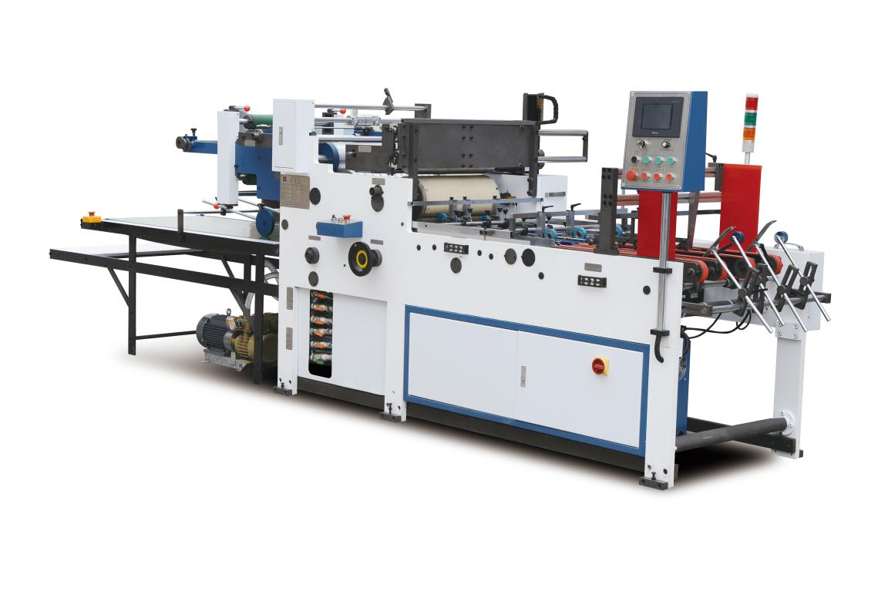

Tangshan Jiguo Printing Machinery Co.,Ltd.
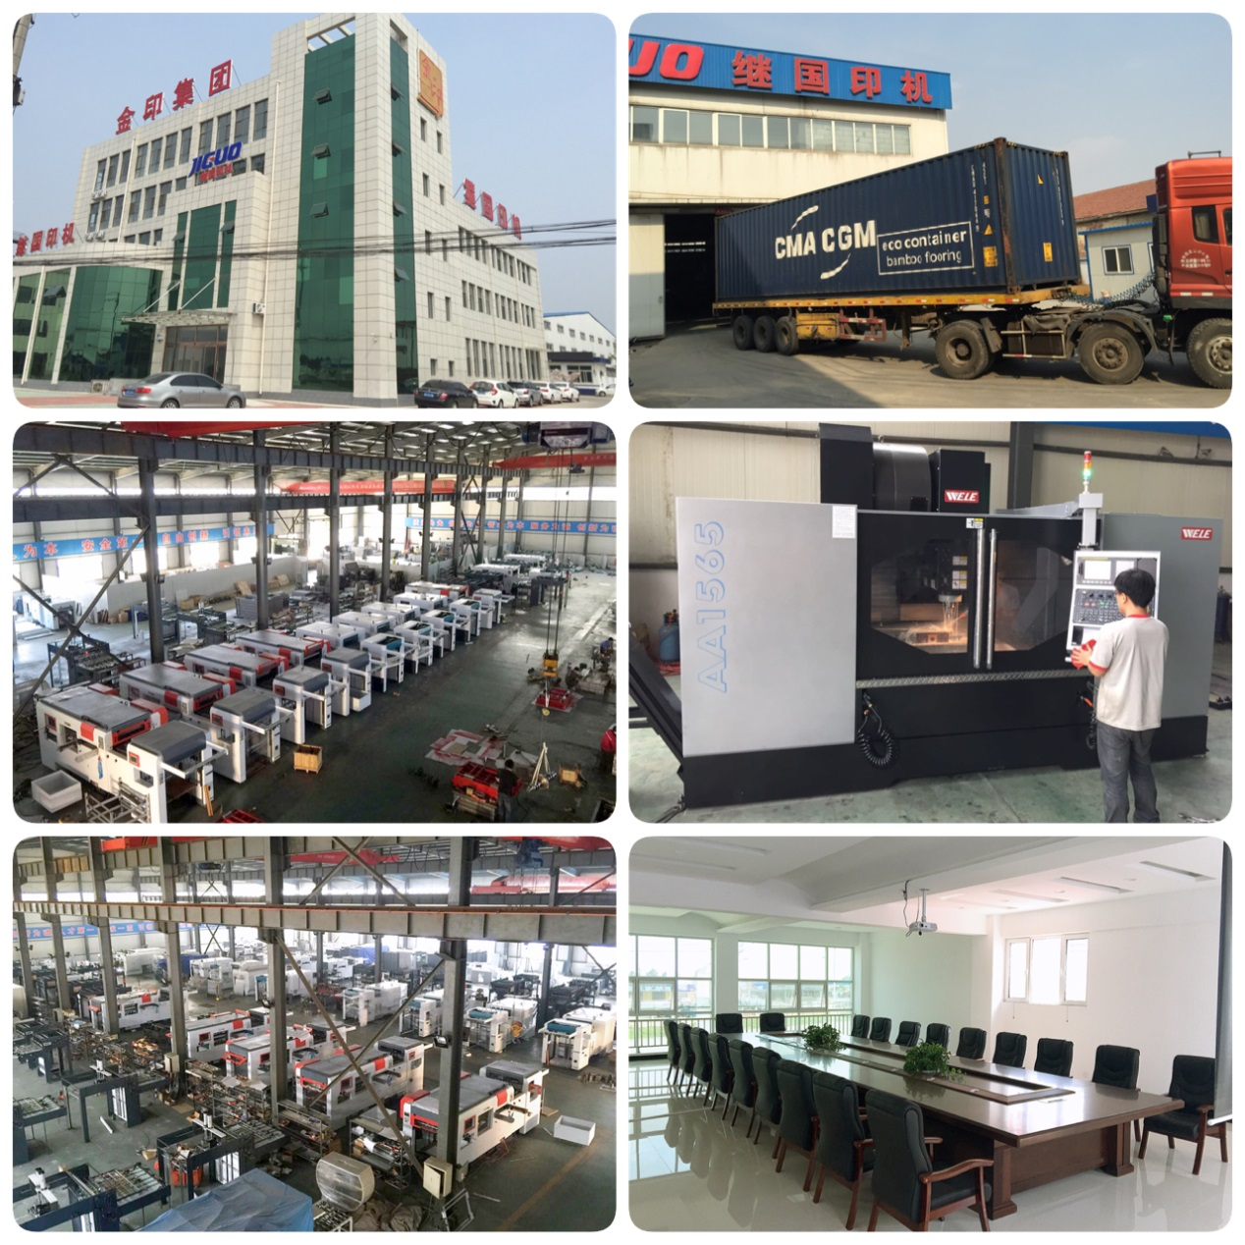
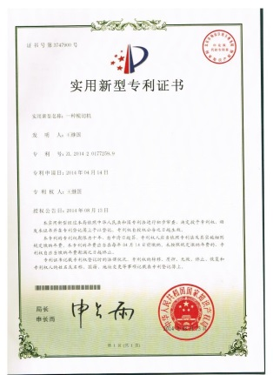
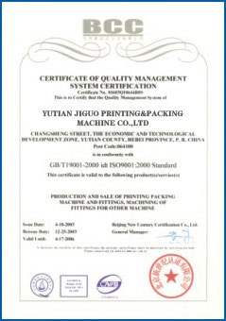
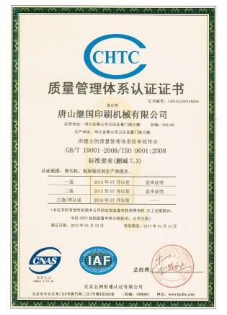
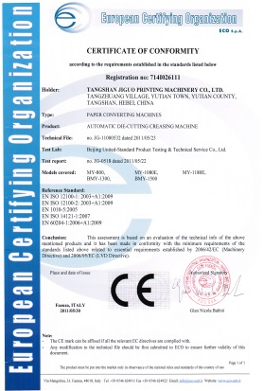
1. Company Profile
Tangshan Jiguo printing machinery Co., LTD., founded in 1996, is a high-tech enterprise started jointly by a number of senior engineers, and is located in the central area of YuTian County within the golden triangle economic zone consisted by Beijing, Tianjin and Tangshan city with 42.81 mu area covered. Our company is specialized in production of post-print paper packaging equipments. Our products have passed the ISO9001 quality certification and the CE certification. We are now mainly producing MY-800/1060/1080E/1200E automatic die-cutting and creasing machine, TMY-800H/1080H automatic die-cutting and foil stamping machine, BMY1320/1500/1650 semi-automatic die-cutting machine and TMB1450/1300 automatic laminating machine, TC-760/1100ABC, TC-1500A Automatic windows patching machine. We have now grown into a well-known domestic post-press equipment manufacturing expert.
2. Machine Pictures

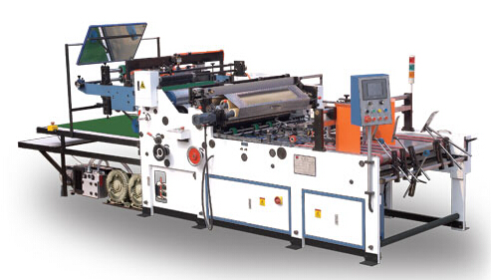
3. Machine Features

Window Patching Machine is widely used in the patching to packing paper articles with window or without window, such as, phone box, wine box, napkin box, clothes box, milk box, card etc.
- It can be used to paste paper onto partial surface of cardboard(paste reinforced paper).
- It can be used to patch films to double or three-side window, and film-creasing, film-punching, film-cutting gaps, especially to PVC、PET films, the max thickness of film is 0.5mm, which highly increases the using scope of window patching machines.
- It can make holes on the surface of reinforced paper, which are corresponding to the handler holes after being pasted with small precision errors.
PLC
Man-machine interface, photo-electric tracing and central control are adopted on the machine to realize the automatic functions of paper feeding, conveying, window gluing or the part flat-gluing, part paper-pasting, film cutting gaps, film patching, paper collecting before folding boxes.(Especially the prepared film cutting and creasing in advance, can avoid furrows when wrap boxes)
The paper feeding part
Adopts servo system, realizing precise inch-move, fast-speed paper-feeding, stable working state and excellent precision in operation. Film feeding part adopts servo system, intermittent actions, the actions speed changes with main motor.
Film cutting-off part
Adopts direct cutter principle, highly increases the use of films thickness scope.

4. Machine Parts Specifications:
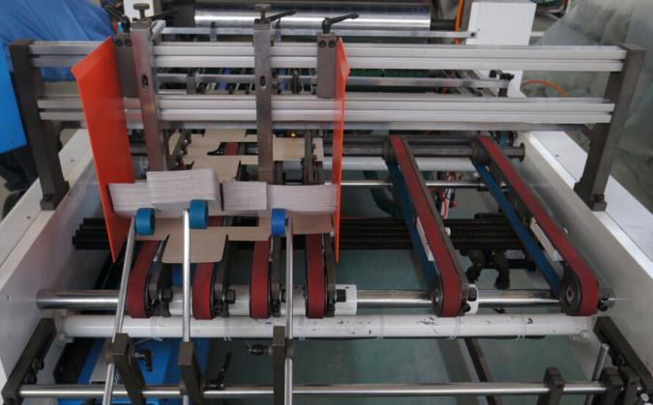 | The Feeding paper Part  The feed paper part apply to various size and thickness, vide range. Apply to cardboard and corrugated board, ect.
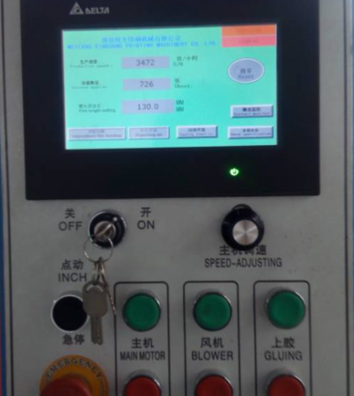 | The Machine Interface Part  This special equipment designed and developed applicable to the windows patching of advanced colorful boxes and cartons with high production efficiency, multi-function, high safety and easy operation to be combined.
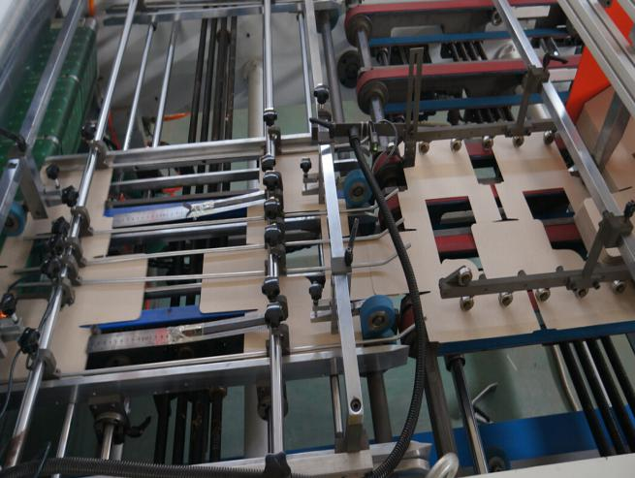 | The Conveying Part  The conveying rubber wheels used in this part are made of high-qualify imported NBR-rubber, which can make better work, without indentions, scratches, tearing-ups etc. thus making it durable and locate the positions of the papers to be processed well, photoelectric tracing helping the work.
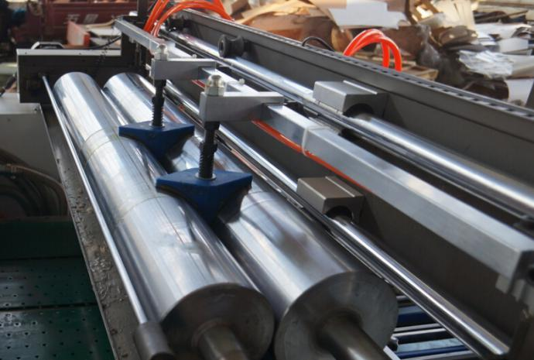 | The gluing Part  The gluing roller is made of high-quality and high-hardness nylon, resistant to acid materials and resistant to corrosion. The volumes of the glue can be adjusted. When it needs to be washed clean, the roller can be pulled out, which makes the cleaning and maintenance easy and convenient.
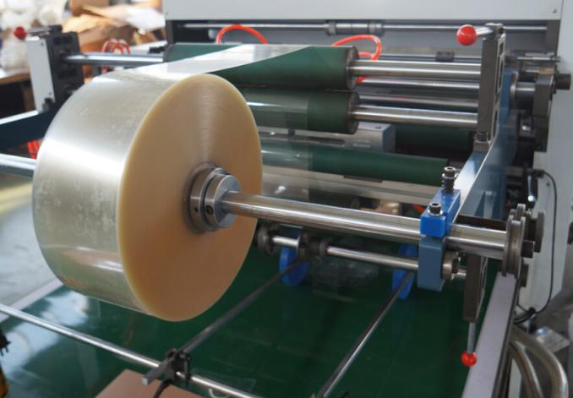 | The film feeding Part  The way of film feeding is multi-roller-pressed and controlled. The size of the film can be adjusted. The unique precise and optional partially cutting-off of the film and the rectifying function together make another unique special of the product.
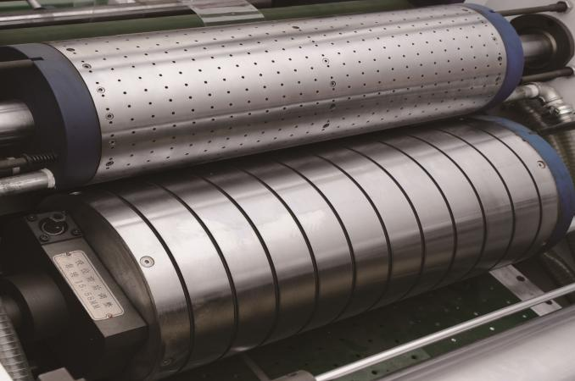 | The film-patching Part  The sucking-blowing theory is adopted here. The position of the window and the film is precise, nearly without error and is able to be adjusted. The whole part is straightforward and easy to operate.
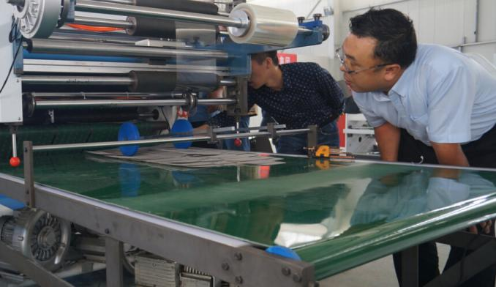 | The Delivery Part  It adopt non-stop automatic delivery system. Increase the work efficiency. Ensure smooth and steady delivery. It can check the product conveniently.
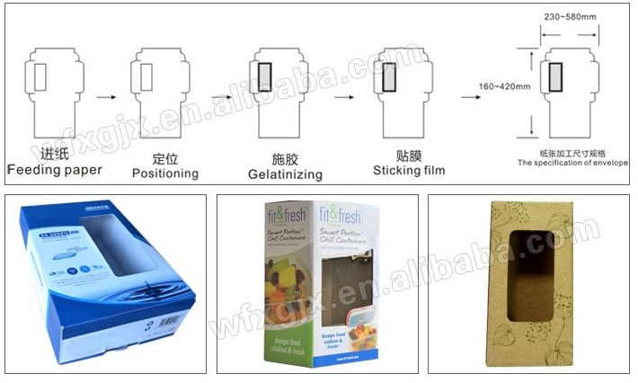 | Patching films（ can make the double or three-sides window）, film creasing and film punching.

5. Details Specifications

Brand | JIGUO
Model | TC-760 (ABC) | TC-1100 (ABC) | TC-1500 A
Max. Paper Size | 760*600mm | 1100*600mm | 1500*1050mm
Min. Paper Size | 200*200mm | 200×200mm | 300*400mm
Max. film Size | 460*380mm | 460×380mm | 500*600mm
Min. film Size | 30*40mm | 60×40mm | 60*60mm
Film Sheet Thickness | 0.05-0.2mm | 0.05-0.20mm | 0.05-0.2mm
Max. Working Speed | 7200s/h (BC-4500s/h) | 6500s/h (BC-4500s/h) | 5000s/h
Cardboard | 250-600g/m² | 250-600g/ m² | 250-600g/ m²
Corrugated Paper | ≤5mm | ≤5mm | ≤5mm
Total Power | 11KW | 13KW | 14.5KW
Total Weight | 2680KG | 2980KG | 3500KG
Overall Dimensions | 4800*1405*1520mm | 4998×1800×1520mm | 5800*2300*1600mm
Overall Dimensions  (When the roller is pulled out) | 4800*2100*1520mm | 4998×2650×1520mm | 4800*3500*1520mm

Remark:
A: The flat window patching;
B: The two line of windows patching at same time;
C: The flat window patching with corner cutting and side creasing models;
6. Payment Terms
30% deposit in advance by T/T., pay 70% rest balance before shipping. You can ask the inspector to inspect the machine before shipping

- Delivery Time
Within 60 days upon receipt of the advanced payment.

- Warranty
One year for all parts.

9. Installation & Training & Service
Seller will send the engineer to buyer’s factory for installation and training. The buyer should pay the round-trip air fare, accommodation and $100 per day per person. Seller should provide the operation and technical knowledge to buyer’s workers. Or the buyer sends their engineer to seller’s company for training. Seller must provide free teaching. The machine’s warranty is 12-month.We have a professional customer service team to support you with installation, after-sales repair, test on site.

- Main Parts Brand

No. | Main parts | Brand | Supplier
1 | Bearing | NSK\FAG | Japan\ Germany
2 | Inverter | INOVANCE | Taiwan
3 | Electrical Component | Schneider | Germany
4 | PLC | INOVANCE | Taiwan
5 | Timing Belt | Qptibelt | Germany
6 | Conveyer belt | EP | USA
7 | Main driving motor | Dedong | China
8 | Servo motor | INOVANCE | Taiwan
9 | Sensor | INOVANCE | Taiwan
10 | man-machine interface | INOVANCE | Taiwan

- This guarantee has legal effect and will not become invalid from company’s development and change.
- Guaranteed by the Jiguo brand, we will continue to provide quality guarantee commitment to you.

